**944747537**

Base URL:

**Agreement URL:**

|  |
| --- |
| https://sigma.yildiz.edu.tr/ |

* **Select the issue from the issue list.**

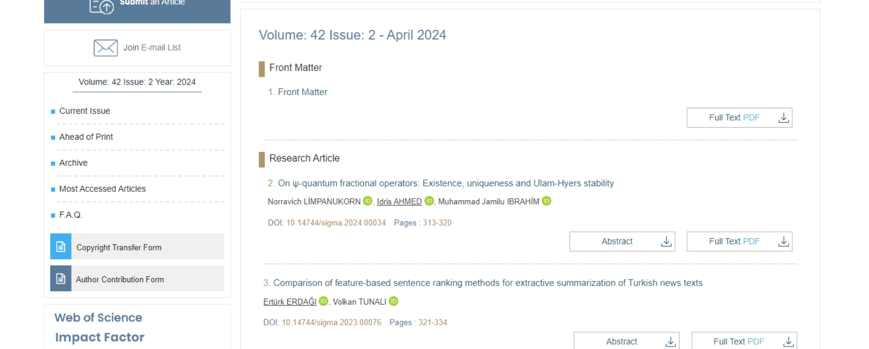

**Select the Current issue from here.**

* **After selecting the issue content will appear here.**

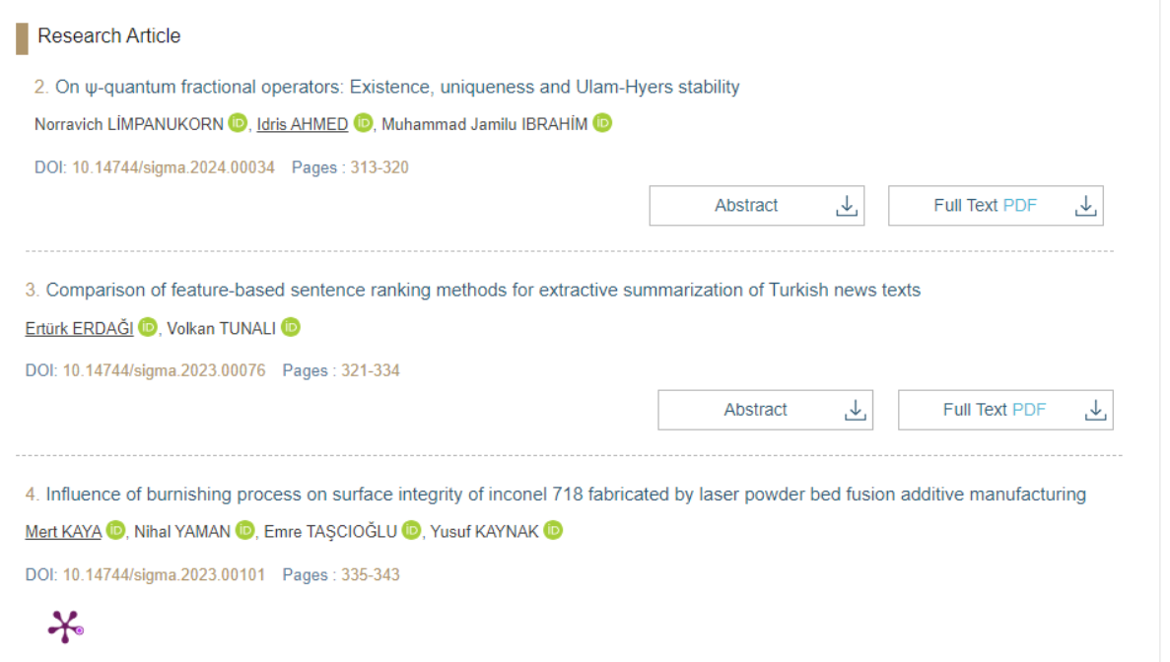

Title

Page range

* **All required articles will be listed here**
* 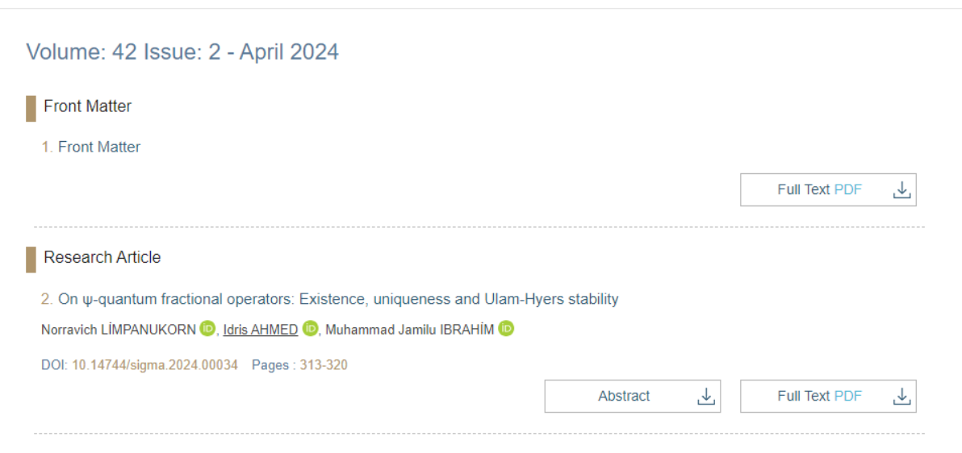

**Volume, issue**

**Month and Year**

**DOI**

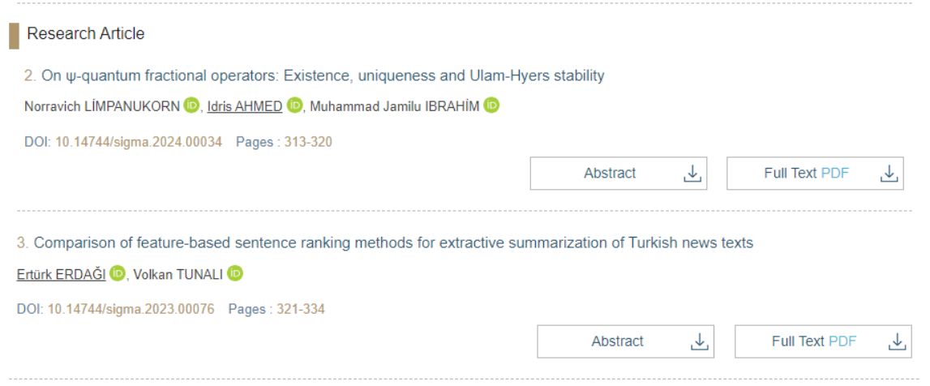

**Then click here to download the pdf**